**Amazon Lookout for Vision Model Training**

1. **Prepare the dataset:** We start by training the model in Amazon Lookout for Vision to learn the differences between normal and anomalous circuit board images.
   1. Open the Amazon Simple Storage Service (Amazon S3), and create a new bucket in the same region as the Amazon Lookout for Vision service. Upload the two folders, **test** and **train**, from the downloaded dataset into the S3 bucket. You should see 60 images in **train** and 20 images in **the test** folder.

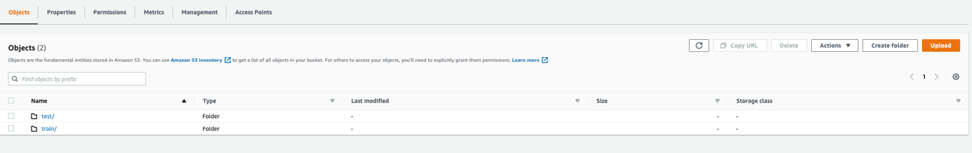

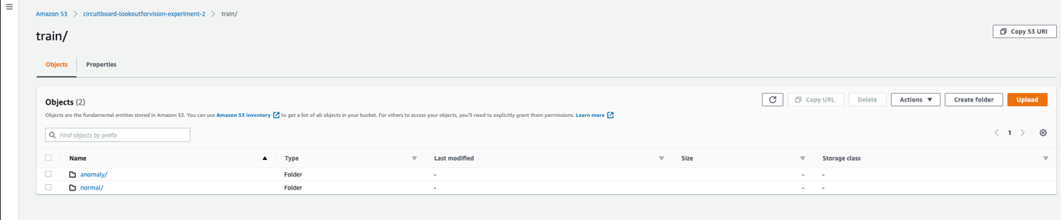

* 1. Open the [Amazon Lookout for Vision](https://console.aws.amazon.com/lookoutvision#/) service on the AWS management console in one of the supported regions. Choose **Get Started** shown in the figure below. The service will ask you to create an S3 bucket if you are using Amazon Lookout for Vision for the first time

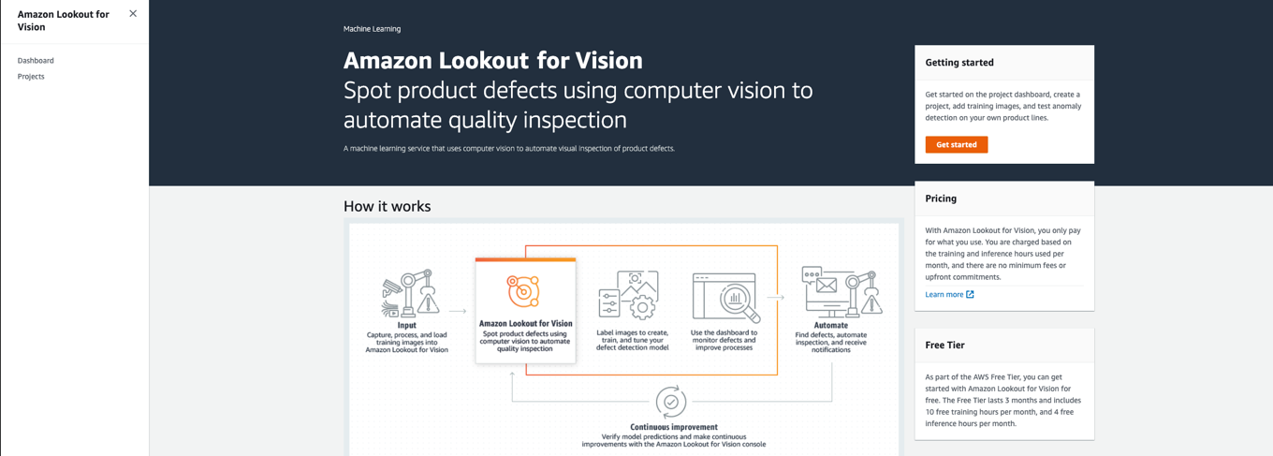

1. **Create Project and Create dataset:** In the Amazon Lookout for Vision console page,
   1. Choose **Create project** to create a new project with a unique name.
   2. Choose **Create dataset**, and select the **Create a training dataset and a test dataset** radio button under **Dataset Configuration**. The remaining selections should match the below figure. Enter the S3 URL pointing to the location of the train folder & Select the checkbox for **Automatic Labeling**

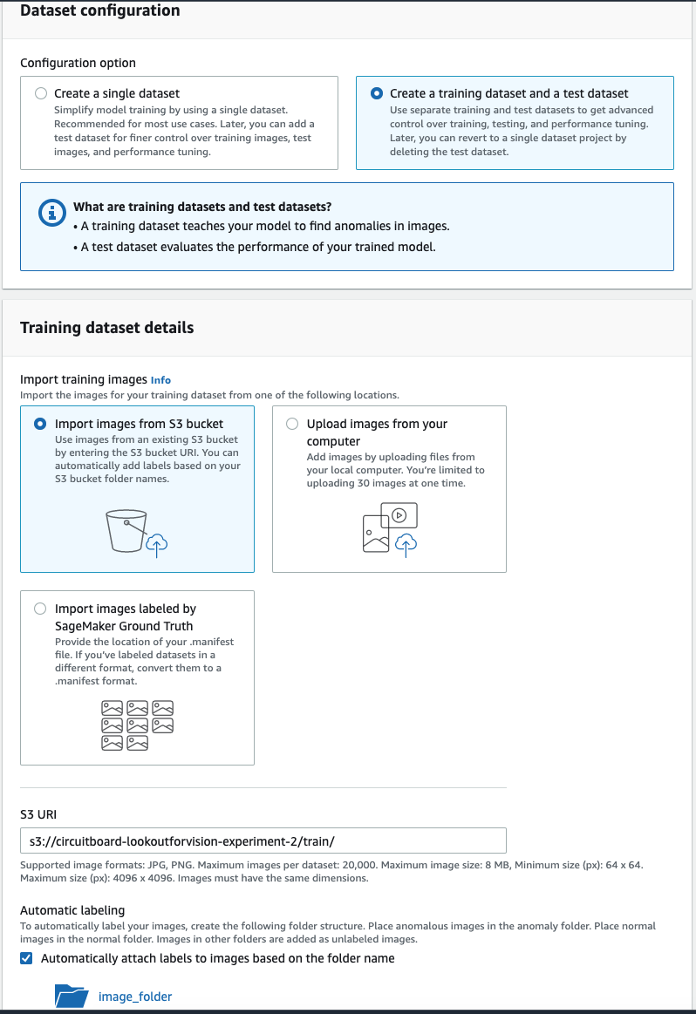

* 1. Repeat the same process for the test dataset details, but make sure the S3 URL is pointing to the test folder in the S3 bucket. Select **Create dataset**

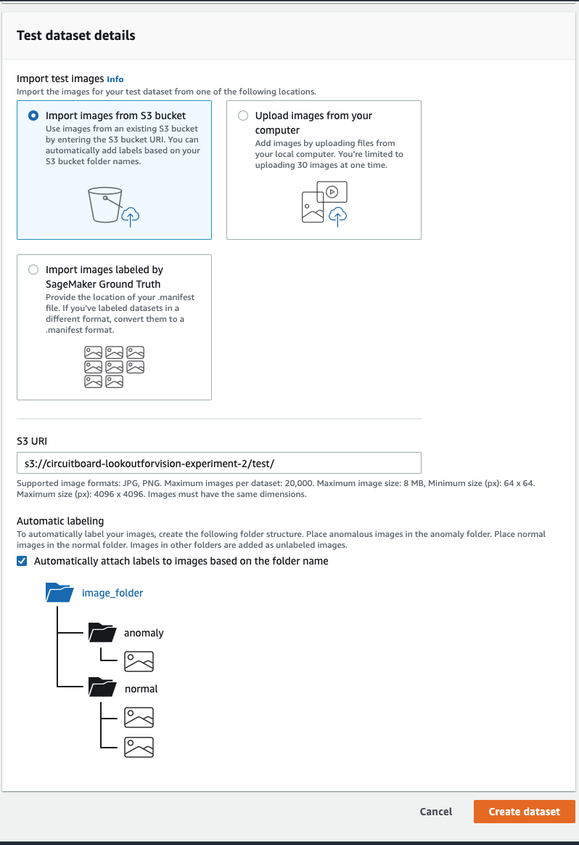

* 1. Check the Dataset in Amazon Lookout for Vision to confirm that 60 labeled images in train and 20 in the test are created with labels as **Anomaly** and **Normal** as highlighted by the figure below.

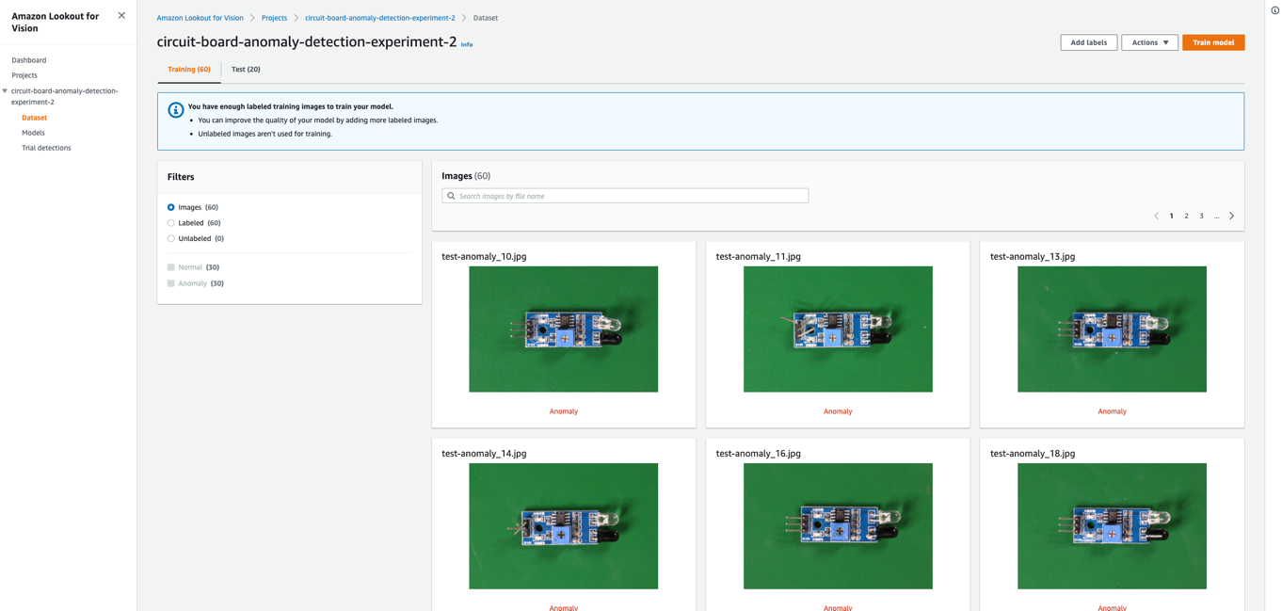

1. **Train the Amazon Lookout for Vision Model:** 
   1. In the Dataset section of the project, select the **Train Model** button as shown in the figure below. Select **Train Model** again on the prompt. Return to the **Models** section of the project and select **Model 1** The model status should show **Training in progress**

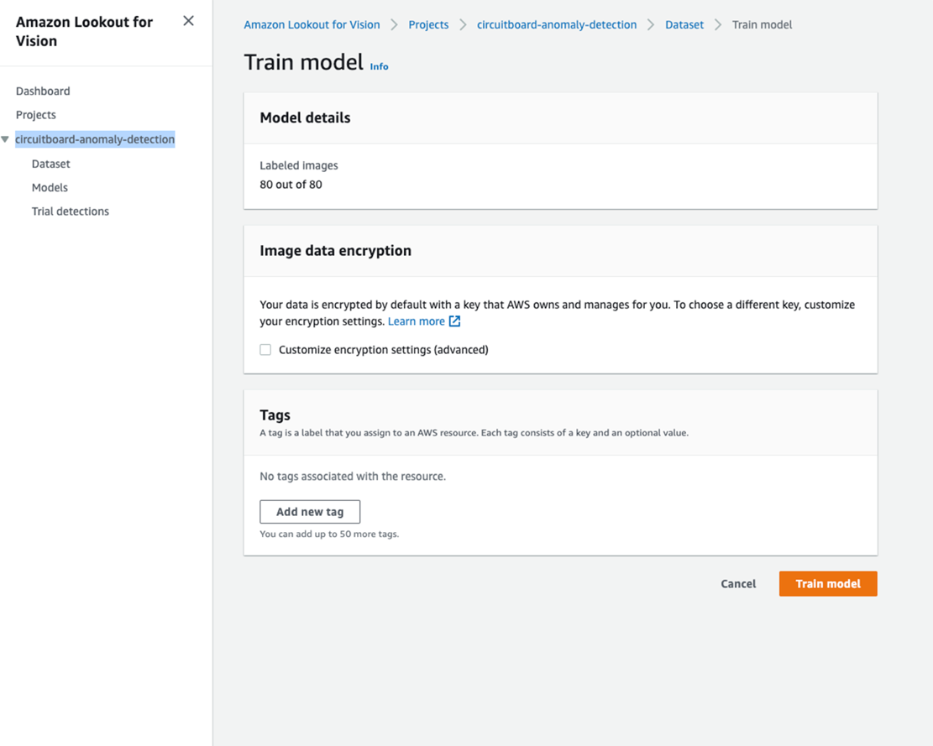

Once the training is complete, Amazon Lookout will show the performance metrics of the test images against the trained model.